**Задачи**

Задача о парикмахере

#include <stdio.h>

#include <stdlib.h>

#include <pthread.h>

#include <semaphore.h>

#include <unistd.h>

#define NUM_SEATS 5

sem_t customers;

sem_t barber;

pthread_mutex_t mutex;

int waiting = 0;

void* barber_thread(void* arg) {

while (1) {

sem_wait(&customers);

pthread_mutex_lock(&mutex);

waiting--;

printf("Barber: taking a customer. Customers waiting: %d\n", waiting);

sem_post(&barber);

pthread_mutex_unlock(&mutex);

printf("Barber: cutting hair...\n");

sleep(3);

}

}

void* customer_thread(void* arg) {

pthread_mutex_lock(&mutex);

if (waiting < NUM_SEATS) {

waiting++;

printf("Customer: sitting in the waiting room. Customers waiting: %d\n", waiting);

sem_post(&customers);

pthread_mutex_unlock(&mutex);

sem_wait(&barber);

printf("Customer: leaving after the haircut.\n");

} else {

printf("Customer: leaving, no free seats.\n");

pthread_mutex_unlock(&mutex);

}

return NULL;

}

int main() {

pthread_t barber_tid;

pthread_t customer_tids[15];

int i;

sem_init(&customers, 0, 0);

sem_init(&barber, 0, 0);

pthread_mutex_init(&mutex, NULL);

pthread_create(&barber_tid, NULL, barber_thread, NULL);

for (i = 0; i < 15; i++) {

pthread_create(&customer_tids[i], NULL, customer_thread, NULL);

sleep(1);

}

for (i = 0; i < 15; i++) {

pthread_join(customer_tids[i], NULL);

}

pthread_join(barber_tid, NULL);

return 0;

}

}

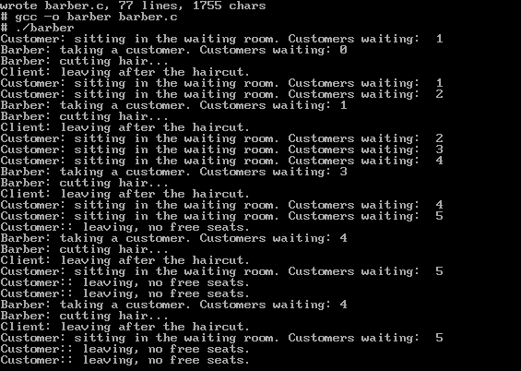

Задача о читателях и писателях

#include <stdio.h>

#include <stdlib.h>

#include <pthread.h>

#include <semaphore.h>

#include <unistd.h>

sem_t resource_access; // Semaphore for resource access (writer)

sem_t read_count_access; // Semaphore for access to reader count

int read_count = 0; // Number of readers

void* reader(void* arg) {

int reader_id = *((int*)arg);

while (1) {

// Reader requests access to the reader count

sem_wait(&read_count_access);

read_count++;

if (read_count == 1) {

// The first reader blocks access to the writer

sem_wait(&resource_access);

}

sem_post(&read_count_access);

// Reading data

printf("Reader %d: reading data\n", reader_id);

sleep(2);

// Reader finishes reading

sem_wait(&read_count_access);

read_count--;

if (read_count == 0) {

// The last reader unlocks the resource for the writer

sem_post(&resource_access);

}

sem_post(&read_count_access);

sleep(1); // Wait before trying to read again

}

}

void* writer(void* arg) {

int writer_id = *((int*)arg);

while (1) {

// Writer requests access to the resource

sem_wait(&resource_access);

// Writing data

printf("Writer %d: writing data\n", writer_id);

sleep(3);

// Writer finishes writing

sem_post(&resource_access);

sleep(2); // Wait before trying to write again

}

}

int main() {

pthread_t readers[5], writers[3];

int reader_ids[5], writer_ids[3];

int i; // Declare variable i outside the loop

// Initialize semaphores

sem_init(&resource_access, 0, 1);

sem_init(&read_count_access, 0, 1);

// Create reader threads

for (i = 0; i < 5; i++) {

reader_ids[i] = i + 1;

pthread_create(&readers[i], NULL, reader, &reader_ids[i]);

}

// Create writer threads

for (i = 0; i < 3; i++) {

writer_ids[i] = i + 1;

pthread_create(&writers[i], NULL, writer, &writer_ids[i]);

}

// Wait for all reader threads to finish

for (i = 0; i < 5; i++) {

pthread_join(readers[i], NULL);

}

// Wait for all writer threads to finish

for (i = 0; i < 3; i++) {

pthread_join(writers[i], NULL);

}

return 0;

}

